Customer Segmentation and Business Insights
Data Science Task #03 — Gexton Education Summer Internship Program
Prepared for: Sir Muhammad Arham MH

1. Project Overview
This project analyzes a small customer dataset (19 records: CustomerID, Age, Gender, Annual Income, and Spending Score) to understand customer behavior and segment customers into meaningful groups using K-Means clustering. The dataset extends the same 19 unique customers used in the Task #02 sales analysis, with demographic and behavioral attributes added to support segmentation.

2. Data Cleaning Process
Initial exploration found one duplicate row (CUST109 appeared twice) and one missing Annual Income value (CUST116). The following cleaning steps were applied:
- Removed 1 duplicate row using drop_duplicates(), reducing the dataset from 19 to 18 records.
- Imputed the missing Annual Income value using the column median (58k), which is robust to the outlier present in the data.
- Checked for outliers using the IQR method on Age and Annual Income. One income outlier was found (CUST118 at 150k, versus an upper bound of ~111.5k) but was kept in the dataset as a genuine high-value customer rather than removed, since it represents a real business segment worth understanding rather than a data error.
- Verified data consistency: no negative values, all Gender values valid ('Male'/'Female'), all Spending Scores within the expected 1-100 range.
The cleaned dataset (18 records, zero missing values, zero duplicates) was saved as customer_data_cleaned.csv.

3. Exploratory Data Analysis Summary
Statistic | Age | Annual Income (k) | Spending Score
Mean | 36.7 | 60.7 | 57.6
Median | 35.5 | 58.0 | 57.5
Std. Dev. | 12.0 | 30.9 | 24.2
Mode | 19 | 58 | 15

The customer base is fairly evenly split by gender (10 Male, 9 Female after cleaning). Correlation analysis revealed two notable relationships: Age and Spending Score are strongly negatively correlated (r = -0.95) — younger customers spend more — while Annual Income and Spending Score are moderately negatively correlated (r = -0.48), meaning higher earners in this sample tend to spend less relative to their income.

4. Data Visualizations
Eight required chart types plus two supporting clustering charts were produced. Selected charts are shown below; all chart files are included as separate PNGs.

Demographics
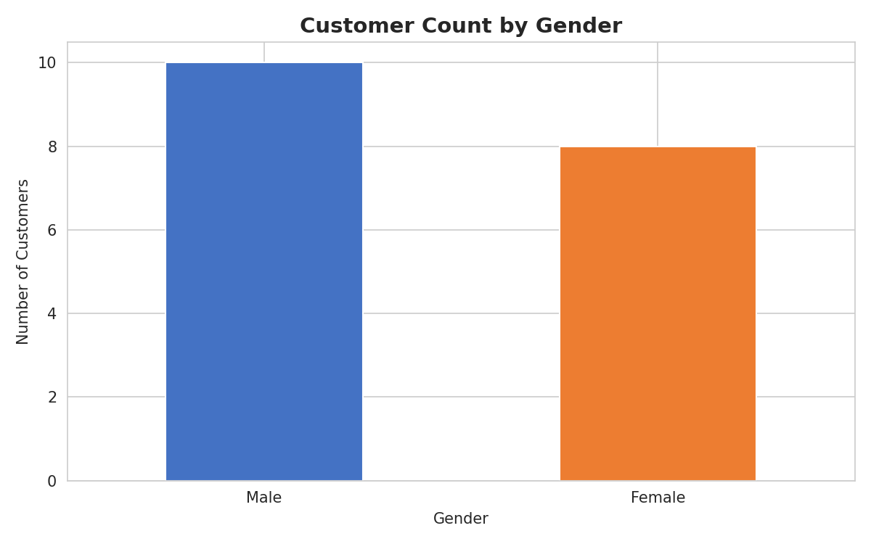 | 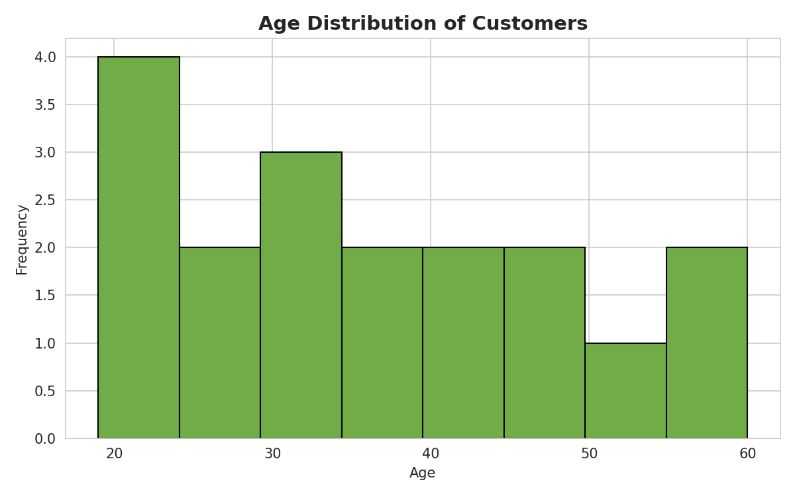
Left: Gender is fairly balanced. Right: Most customers are aged 20-45, with a smaller older tail.

Income & Spending Distribution
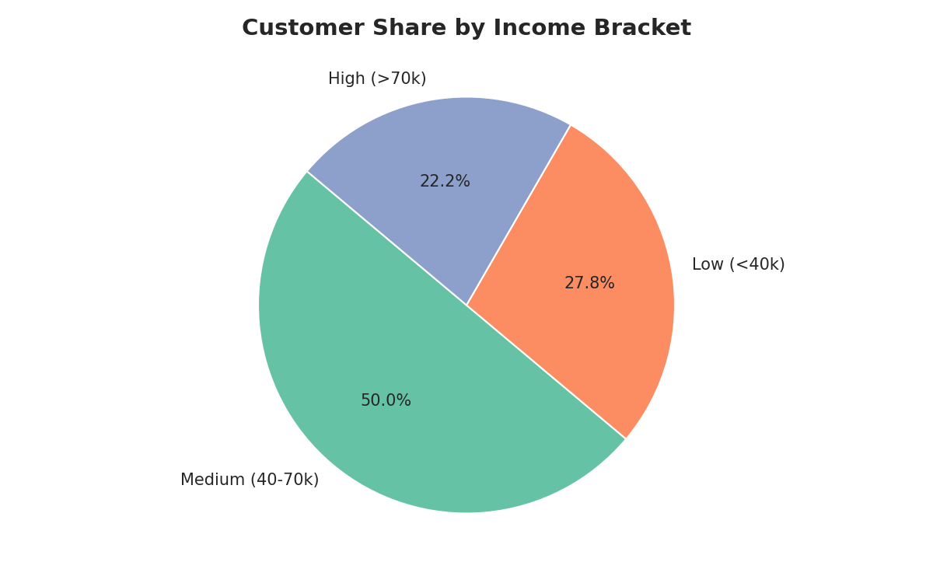 | 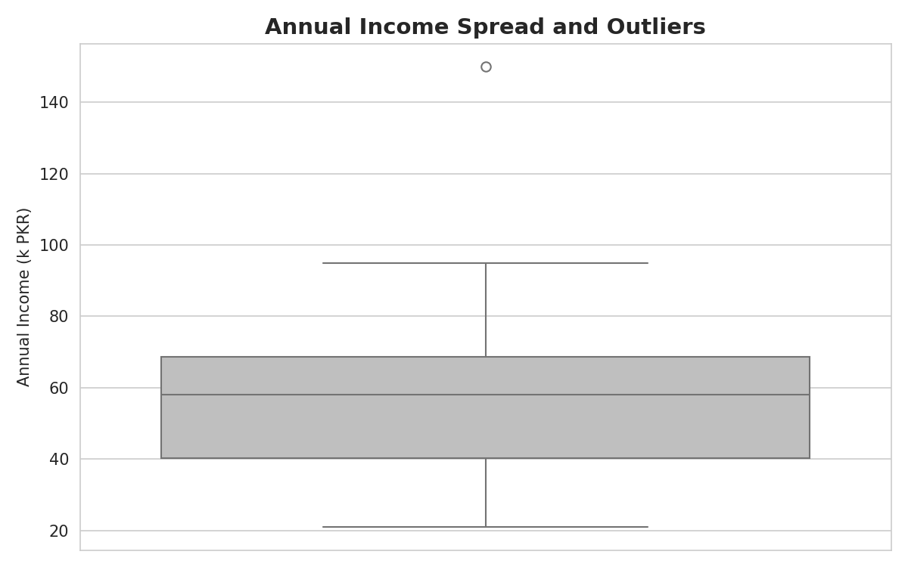
Left: Customers split roughly evenly across low/medium/high income brackets. Right: One clear high-income outlier (CUST118, 150k) sits above the upper whisker.

Spending Score by Gender
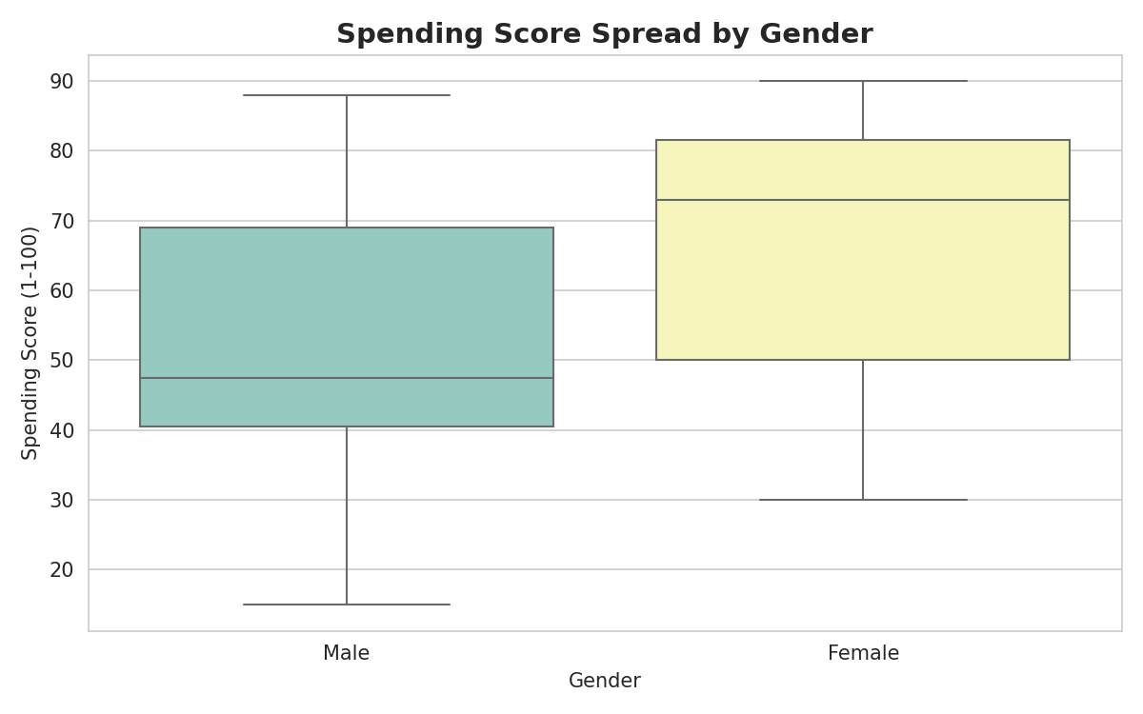
Female customers show a slightly higher median spending score with a wider spread than male customers.

Relationships Between Variables
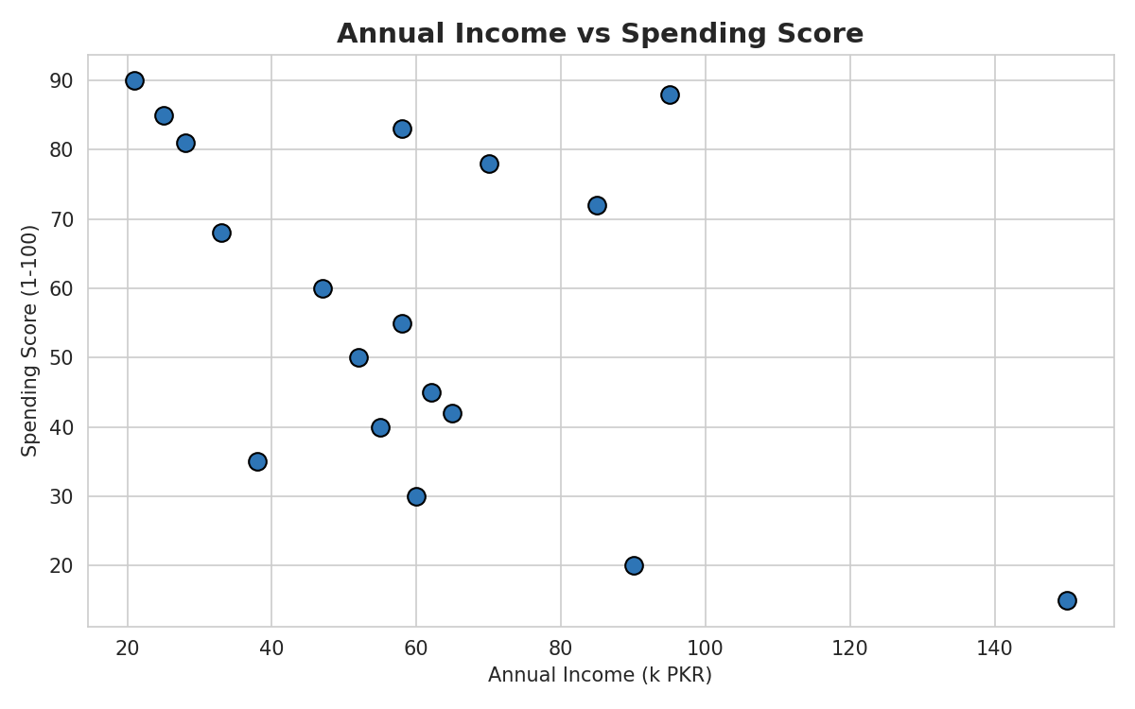 | 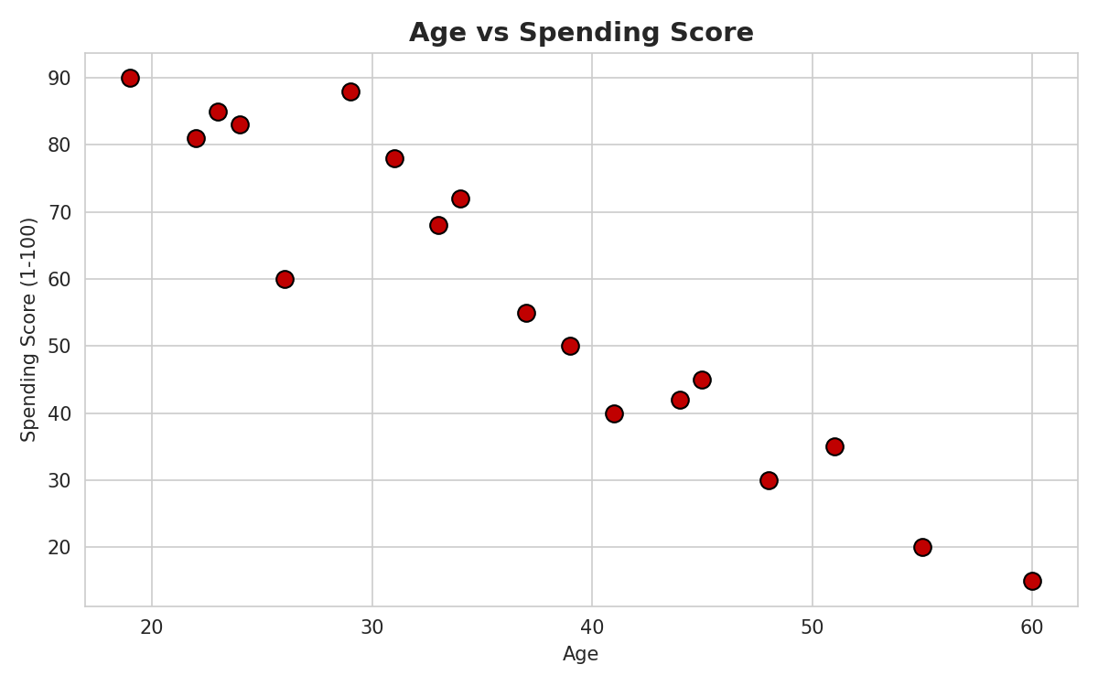
Left: Higher income generally pairs with lower spending score, except a low-income/high-spend group. Right: Spending score clearly declines with age.

Correlation Heatmap
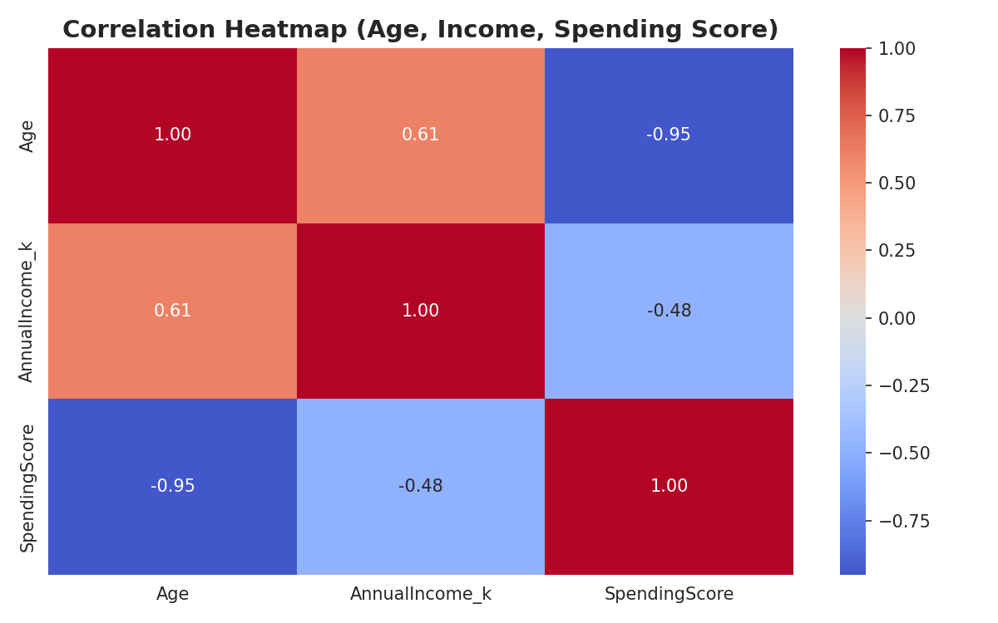
Age shows a strong negative correlation with Spending Score (-0.95); Income shows a moderate negative correlation with Spending Score (-0.48).

5. Customer Segmentation Results
K-Means clustering was applied to Annual Income and Spending Score (standardized using StandardScaler). The Elbow Method was used to identify the optimal number of clusters — inertia decreases sharply up to k=3 and flattens afterward, so k=3 was selected given the small sample size.
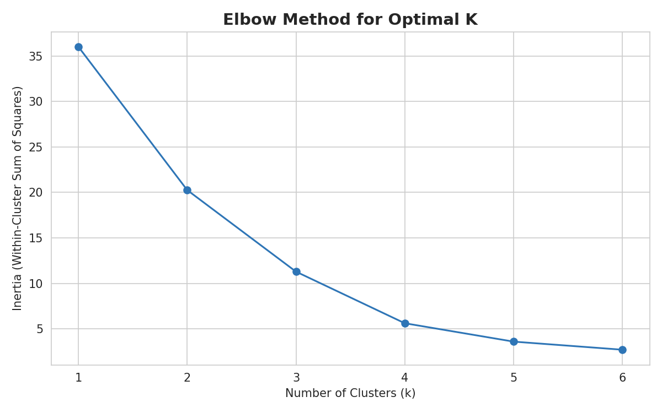

The resulting three segments and their average characteristics:
Cluster | Count | Avg. Age | Avg. Income (k) | Avg. Spend Score | Segment Label
0 | 8 | 45.0 | 60.0 | 39.6 | Conservative
1 | 9 | 26.8 | 51.3 | 78.3 | High-Spend / Engaged
2 | 1 | 60.0 | 150.0 | 15.0 | High Income, Low Engagement

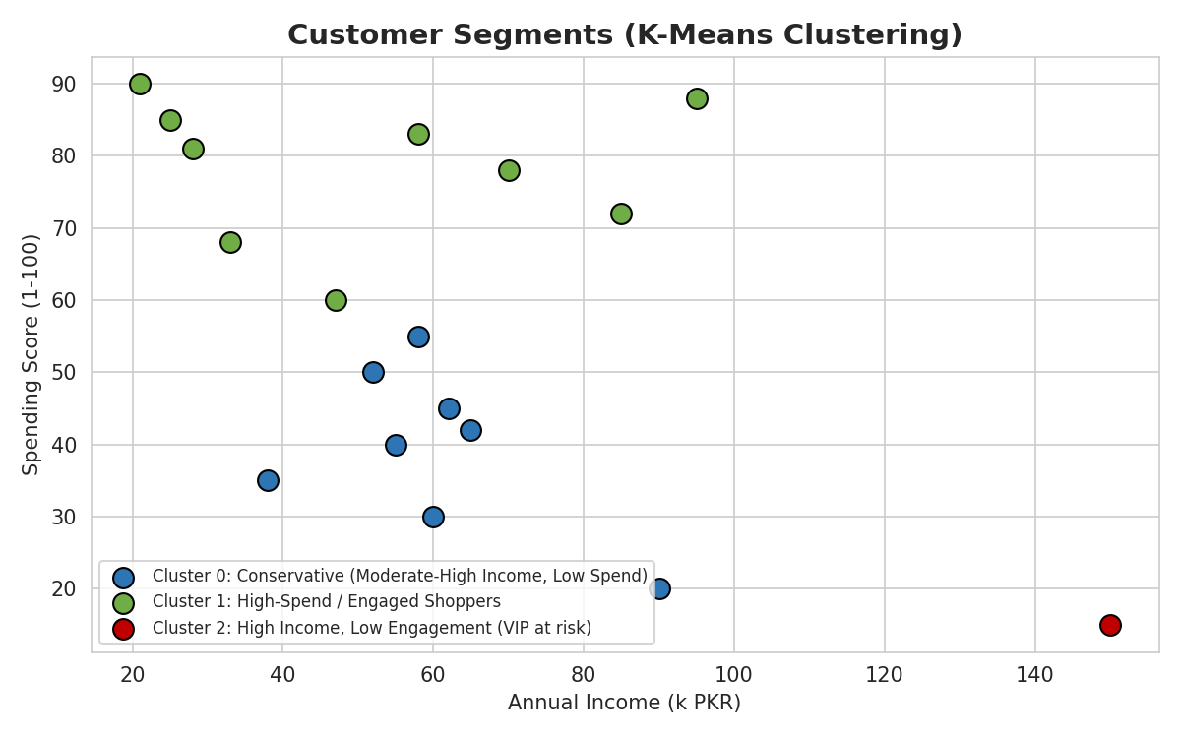

Cluster Interpretation
- Cluster 0 - Conservative (8 customers, ~44% of base): Moderate-to-high income but low spending score. These are financially capable customers who are under-engaged with the business.
- Cluster 1 - High-Spend / Engaged Shoppers (9 customers, ~50% of base): Younger customers with moderate income but high spending scores. This is the largest and most actively engaged segment.
- Cluster 2 - High Income, Low Engagement (1 customer, CUST118): A clear outlier - the highest income in the dataset (150k) but the lowest spending score (15). Represents a high-potential, currently under-served VIP customer.

6. Business Insights and Recommendations
- The High-Spend/Engaged segment (Cluster 1) is the most valuable for current revenue, despite not having the highest income - engagement matters more than income alone for driving spending in this customer base.
- The Conservative segment (Cluster 0) represents a significant untapped opportunity: they have the income to spend more but currently don't. Targeted promotions, loyalty incentives, or personalized offers could shift this group toward higher engagement.
- CUST118 (Cluster 2) should be treated as a VIP-at-risk: high income but very low spending score suggests dissatisfaction, lack of relevant offerings, or simply being an untapped premium customer. A dedicated relationship-management or premium-product approach is recommended.
- Marketing strategy by segment: for Cluster 1, reinforce loyalty with rewards programs to retain already-high engagement; for Cluster 0, use re-engagement campaigns (e.g. limited-time offers, personalized recommendations) to convert income into spending; for Cluster 2, consider a white-glove/VIP outreach approach rather than mass marketing.
- The strong negative correlation between Age and Spending Score (-0.95) suggests products and marketing should be tailored toward younger demographics to maximize spending, while a separate strategy is needed to re-engage older, higher-income customers.
- Because Income and Spending Score are negatively correlated overall, revenue growth should not rely solely on attracting high-income customers - engagement and relevance to the customer's needs appear to matter more than income level.
- Given the small sample size (18-19 customers), these segments are illustrative of the workflow rather than statistically robust; collecting more customer records would allow more reliable cluster boundaries and likely reveal additional segments.

7. Final Conclusion
This analysis demonstrates a complete customer segmentation workflow: cleaning a small but realistically messy dataset, exploring demographic and behavioral patterns, visualizing key relationships, and applying K-Means clustering to identify three distinct customer segments. The clearest actionable finding is that spending engagement, not income, is the primary driver of customer value in this dataset - meaning business strategy should prioritize engagement-building activities over income-based targeting alone. The same workflow and code structure used here would scale directly to a larger customer base for more statistically reliable segmentation.

8. Tools Used
- Python: Pandas and NumPy for data cleaning and analysis
- Matplotlib and Seaborn for visualizations
- Scikit-learn (KMeans, StandardScaler) for customer segmentation
- Deliverables: customer_data_raw.csv, customer_data_cleaned.csv, customer_data_segmented.csv, analysis.py, all chart PNGs, and this report

